Week 3 Task: Risk Analysis
Banking-System Risk Assessment Using World Bank Indicators
Public source: World Bank World Development Indicators (WDI)
Analytical continuity: Week 1 financial-system dataset and Week 2 India NPL forecast

1. Executive Summary
This report identifies and assesses key financial-system risks using the indicators established in Week 1 and the India non-performing loan (NPL) forecast developed in Week 2. The analysis focuses on asset quality, capitalization, credit depth, model uncertainty, data comparability, and the limitations of relying on aggregate financial indicators. Risk likelihood and impact are assessed qualitatively using a three-level scale: Low, Medium, and High. The resulting risk register highlights asset-quality deterioration and capital pressure as potentially high-impact banking risks, while also identifying forecast uncertainty and data comparability as important analytical risks. The objective is not to predict a banking crisis, but to demonstrate a structured process for identifying financial risks, evaluating their potential significance, and proposing practical mitigation actions.

2. Data and Analytical Basis
The Week 1 analysis used three World Bank indicators: bank capital to assets, non-performing loans as a percentage of gross loans, and domestic credit to the private sector provided by banks as a percentage of GDP. The Week 1 report found substantial variation across the 15-country sample: capital-to-assets ranged from 4.07% to 13.73%, NPLs from 0.46% to 5.31%, and private-sector credit from 26.56% to 194.17% of GDP. The observation year was retained for each country and indicator because the latest available observation differed across the sample. fileciteturn5file0L22-L38
For Week 2, India was selected for a basic NPL forecast. Historical observations from 2011–2023 were used and a three-year moving-average baseline produced forecasts of 4.33% for 2024, 3.61% for 2025, and 3.21% for 2026. These are model outputs, not guarantees of future outcomes.

3. Risk Identification
- Asset-quality deterioration: A rise in NPLs can indicate weakening borrower repayment capacity and can increase credit losses, provisioning needs and pressure on bank capital.
- Forecast/model uncertainty: A simple moving-average forecast is transparent but can react slowly to structural breaks, sudden shocks or changes in the credit cycle.
- Data comparability and timing risk: Cross-country indicators may refer to different observation years, making direct comparisons less precise.
- Credit-cycle and concentration risk: Very different levels of private-sector credit indicate different degrees of credit-market depth and potential exposure to excessive leverage or concentration.
- Capital adequacy pressure: Lower capitalization can reduce the capacity of banks to absorb unexpected losses, particularly if asset quality deteriorates.
- Over-reliance on aggregate indicators: Three high-level indicators cannot capture every relevant source of banking risk, such as liquidity, profitability, provisioning or sector-specific exposures.

4. Risk Assessment Method
Likelihood measures how plausible the risk is within the analytical context, while impact measures the potential severity if the risk materializes. Each is rated Low, Medium or High. A simple qualitative score is calculated as Low=1, Medium=2 and High=3, with Score = Likelihood × Impact. Scores of 1–2 are treated as lower priority, 3–4 as moderate priority, and 6–9 as higher priority. This is a screening framework rather than a regulatory capital or credit-risk model.

5. Risk Register
ID | Risk | Likelihood | Impact | Score | Mitigation
R1 | Asset-quality deterioration | Medium | High | 6 | Monitor NPL trends, sector concentration, loan restructuring and provisioning; strengthen early-warning indicators.
R2 | Forecast/model uncertainty | High | Medium | 6 | Back-test the model, compare with alternative models, use prediction intervals and refresh forecasts as new observations arrive.
R3 | Data comparability / timing risk | High | Medium | 6 | Align common years for cross-country analysis and preserve observation-year fields in all downstream analysis.
R4 | Credit-cycle / concentration risk | Medium | High | 6 | Monitor rapid credit growth, sector/geographic concentration, underwriting standards and borrower leverage.
R5 | Capital adequacy pressure | Medium | High | 6 | Maintain capital buffers, conduct stress tests and monitor capital adequacy under adverse credit scenarios.
R6 | Over-reliance on aggregate indicators | Medium | Medium | 4 | Add profitability, liquidity, provisioning, GDP growth, inflation and lending-rate indicators before making high-stakes decisions.

6. Risk Matrix
The matrix below summarizes the qualitative positioning of the six identified risks. Several risks fall into the higher-priority category because they combine medium/high likelihood with high potential impact.
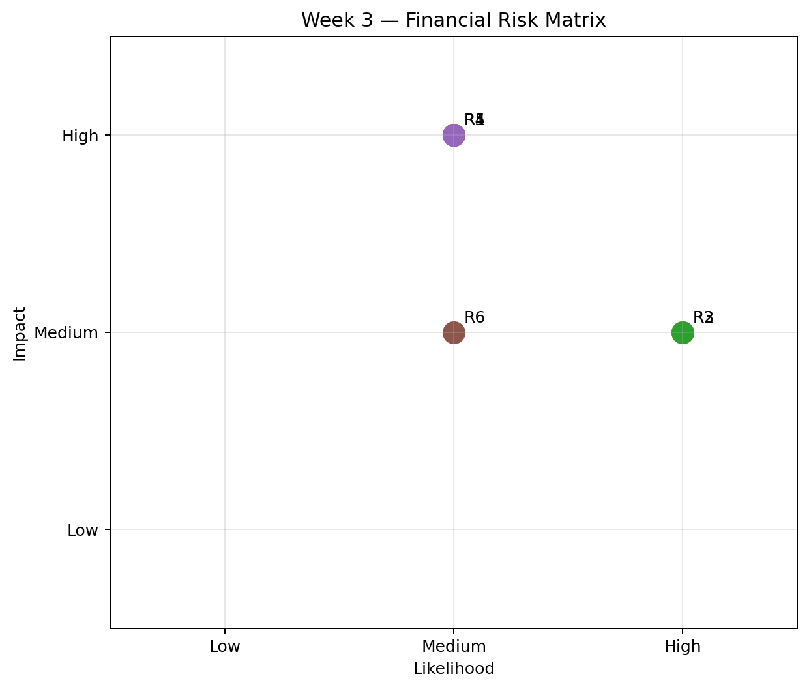

7. Detailed Risk Discussion and Mitigation

R1 — Asset-quality deterioration
The NPL ratio is a direct indicator of loan-asset quality. India's historical series shows a pronounced increase during 2015–2018 before falling substantially by 2023. This demonstrates that asset quality can change materially over a relatively short period. A renewed increase could raise provisioning requirements and reduce earnings. Mitigation should focus on early-warning indicators, sector-level exposure monitoring, borrower stress testing, loan restructuring controls and adequate provisioning.

R2 — Forecast/model uncertainty
The Week 2 model is intentionally simple. A three-year moving average provides a transparent baseline, but it does not explicitly model macroeconomic variables, structural breaks or nonlinear credit-cycle effects. Therefore, forecast error is a material analytical risk. The mitigation is to back-test the model, compare it with alternative methods such as exponential smoothing or ARIMA, and report forecast intervals rather than relying only on point estimates.

R3 — Data comparability and timing risk
Week 1 deliberately retained observation years because the latest available year differed across countries and indicators. Comparing values from different years can mix structural differences with differences caused by economic conditions at the time of measurement. The best mitigation is to construct a common-year panel for cross-country comparisons and keep the original observation dates available for auditability.

R4 — Credit-cycle and concentration risk
Private-sector credit ranged widely across the Week 1 sample. High credit depth is not automatically a problem, but rapid growth, weak underwriting or concentration can increase vulnerability when economic conditions deteriorate. Mitigation should include monitoring credit growth, borrower leverage, sector concentration and underwriting standards.

R5 — Capital adequacy pressure
Bank capital provides an important loss-absorption buffer. The Week 1 sample showed a wide range in capital-to-assets ratios. A bank facing higher NPLs may need to absorb losses through earnings and capital. Mitigation should include capital buffers, stress testing and monitoring of capital adequacy under adverse scenarios.

R6 — Over-reliance on aggregate indicators
The selected indicators provide a useful starting point but do not represent the entire risk profile of a banking system. Liquidity, profitability, interest-rate risk, foreign-currency exposure, provisioning and macroeconomic conditions can materially change the interpretation. A broader dashboard should therefore be used before making high-stakes decisions.

8. Key Findings
- Asset quality is a central banking risk because changes in NPLs can affect provisions, earnings and capital.
- The India NPL forecast provides a useful baseline, but the simplicity of the model creates forecast uncertainty.
- Data timing is an important analytical risk when comparing countries because the latest observations are not necessarily from the same year.
- Capitalization and credit depth should be monitored together with asset quality rather than interpreted independently.
- Risk mitigation should combine quantitative indicators with stress testing, early-warning monitoring and additional macro-financial variables.

9. Limitations
This analysis is a structured screening exercise rather than a full banking-sector stress test. The Week 1 sample contains 15 countries and uses the latest available observation for each selected indicator, so the observations are not a perfectly synchronized panel. The Week 2 forecast is a simple baseline and should not be treated as an investment recommendation or a regulatory forecast. Risk ratings are qualitative and intended for prioritization. A stronger future analysis would use a full historical panel, common observation years, macroeconomic variables, bank-level data where available, and statistically validated forecasting and stress-testing models.

10. Sources and Reproducibility
Primary data source: World Bank World Development Indicators (WDI). The Week 1 project used the following indicator codes: FB.BNK.CAPA.ZS (bank capital to assets), FB.AST.NPER.ZS (NPLs to gross loans), and FD.AST.PRVT.GD.ZS (private credit to GDP). The Week 1 report documents the data-cleaning process and notes that the Python workflow uses the public World Bank API. fileciteturn5file8L616-L625

